SEC Form 4

FORM 4

Check this box if no longer subject to Section 16. Form 4 or Form 5 obligations may continue. See Instruction 1(b).

UNITED STATES SECURITIES AND EXCHANGE COMMISSION
Washington, D.C. 20549
 |  | OMB APPROVAL
STATEMENT OF CHANGES IN BENEFICIAL OWNERSHIP
 |  | OMB Number: | 3235-0287
 |  | Estimated average burden
Filed pursuant to Section 16(a) of the Securities Exchange Act of 1934 |  | hours per response: | 0.5
or Section 30(h) of the Investment Company Act of 1940
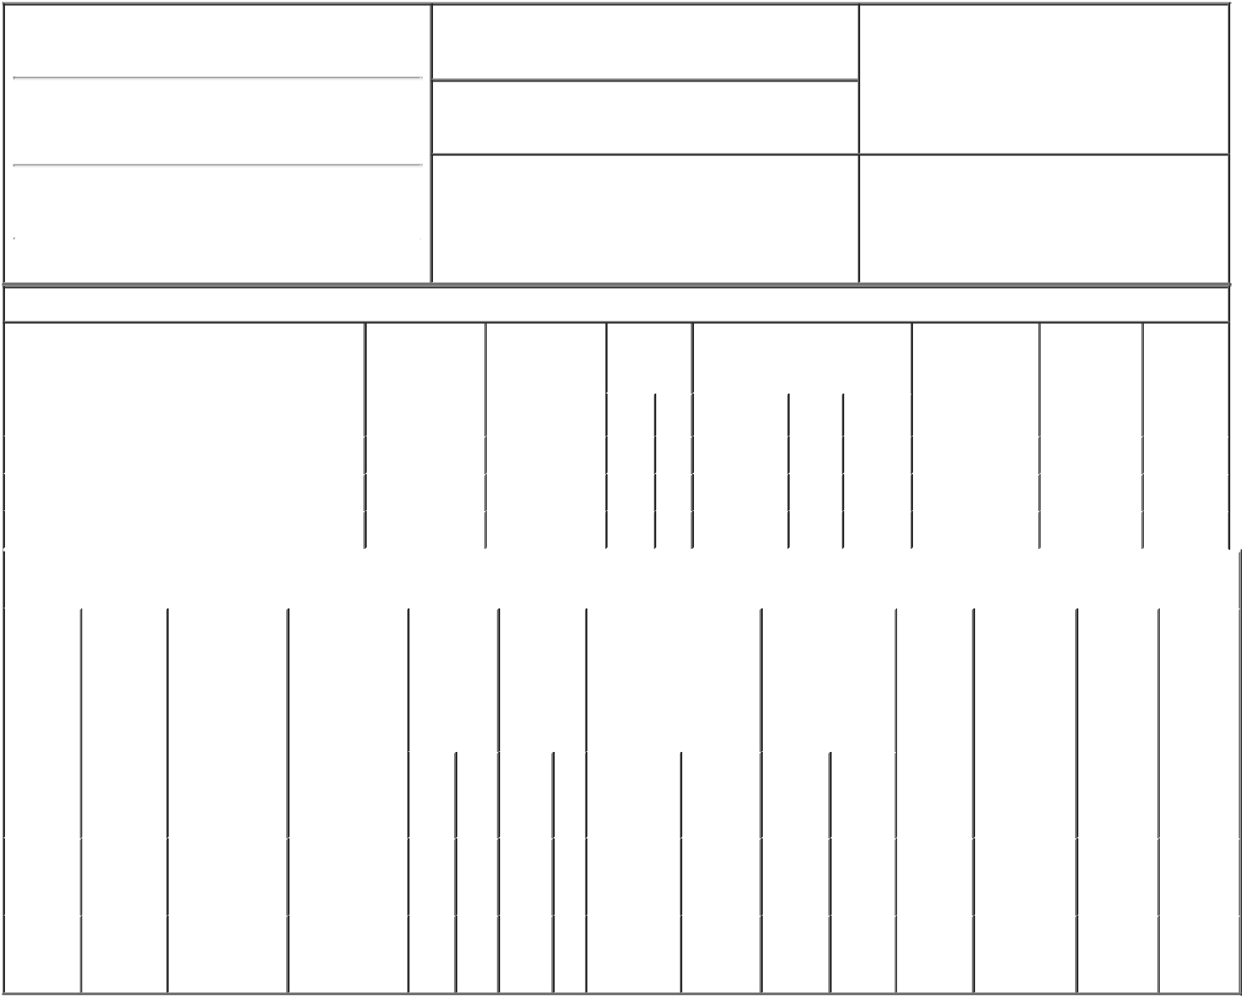

1. Name and Address of Reporting Person*
Glickman Todd

(Last) (First) (Middle)

22 FITZWILLIAM SQUARE

2. Issuer Name and Ticker or Trading Symbol

Navitas Semiconductor Corp [ NVTS ]

3. Date of Earliest Transaction (Month/Day/Year)
10/19/2021

- Relationship of Reporting Person(s) to Issuer (Check all applicable)

 | Director | 10% Owner
X | Officer (give title | Other (specify
 | below) | below)

Interim Chf Financial Officer

(Street)
 | DUBLIN | L2 | D02 FH68
 | (City) | (State) | (Zip)

4. If Amendment, Date of Original Filed (Month/Day/Year) 6. Individual or Joint/Group Filing (Check Applicable
Line)
X Form filed by One Reporting Person

Form filed by More than One Reporting
Person

Table I - Non-Derivative Securities Acquired, Disposed of, or Beneficially Owned

 | 1. Title of Security (Instr. 3) |  |  | 2. Transaction |  | 2A. Deemed |  | 3. |  | 4. Securities Acquired (A) or |  |  |  |  |  | 5. Amount of |  | 6. Ownership |  | 7. Nature of
 |  |  |  | Date |  | Execution Date, |  |  | Transaction | Disposed Of (D) (Instr. 3, 4 and 5) |  |  |  |  |  | Securities |  | Form: Direct |  | Indirect
 |  |  |  | (Month/Day/Year) |  | if any |  |  | Code (Instr. |  |  |  |  |  |  | Beneficially |  | (D) or Indirect |  | Beneficial
 |  |  |  |  |  | (Month/Day/Year) 8) |  |  |  |  |  |  |  |  |  | Owned Following |  | (I) (Instr. 4) |  | Ownership
 |  |  |  |  |  |  |  |  |  |  |  |  |  |  |  | Reported |  |  |  | (Instr. 4)
 |  |  |  |  |  |  |  |  | Code V | Amount |  | (A) or | Price |  |  | Transaction(s)
 |  |  |  |  |  |  |  |  |  |  |  | (D) |  |  |  | (Instr. 3 and 4)
 | Common Stock |  |  | 10/19/2021 |  |  |  |  | A | 225,240⁽¹⁾ |  | A | (1) |  | 225,240 |  |  |  | D
 | Common Stock |  |  | 10/19/2021 |  |  |  |  | A | 147,744⁽²⁾ |  | A | $0 |  | 372,984 |  |  |  | D
 | Common Stock |  |  | 10/19/2021 |  |  |  |  | A | 547,200⁽³⁾ |  | A | $0 |  | 920,184 |  |  |  | D
 |  |  |  | Table II - Derivative Securities Acquired, Disposed of, or Beneficially Owned
 |  |  |  | (e.g., puts, calls, warrants, options, convertible securities)
 | 1. Title of | 2. | 3. Transaction | 3A. Deemed | 4. | 5. Number |  | 6. Date Exercisable and |  |  | 7. Title and Amount |  |  |  | 8. Price of |  | 9. Number of |  | 10. | 11. Nature
 | Derivative | Conversion | Date | Execution Date, | Transaction | of |  | Expiration Date |  |  | of Securities |  |  |  | Derivative |  | derivative |  | Ownership of Indirect
 | Security | or Exercise | (Month/Day/Year) | if any | Code (Instr. | Derivative |  | (Month/Day/Year) |  |  | Underlying |  |  |  | Security |  | Securities |  | Form: | Beneficial
 | (Instr. 3) | Price of |  | (Month/Day/Year) | 8) | Securities |  |  |  |  | Derivative Security |  |  |  | (Instr. 5) |  | Beneficially |  | Direct (D) | Ownership
 |  | Derivative |  |  |  | Acquired |  |  |  |  | (Instr. 3 and 4) |  |  |  |  |  | Owned |  | or Indirect | (Instr. 4)
 |  | Security |  |  |  | (A) or |  |  |  |  |  |  |  |  |  |  | Following |  | (I) (Instr. 4)
 |  |  |  |  |  | Disposed |  |  |  |  |  |  |  |  |  |  | Reported
 |  |  |  |  |  | of (D) (Instr. |  |  |  |  |  |  |  |  |  |  | Transaction(s)
 |  |  |  |  |  | 3, 4 and 5) |  |  |  |  |  |  |  |  |  |  | (Instr. 4)
 |  |  |  |  |  |  |  |  |  |  |  |  | Amount
 |  |  |  |  |  |  |  |  |  |  |  |  | or
 |  |  |  |  |  |  |  |  |  |  |  |  | Number
 |  |  |  |  |  |  |  | Date |  | Expiration |  |  | of
 |  |  |  |  | Code V | (A) | (D) | Exercisable |  | Date | Title |  | Shares
 | Stock
 | Option | $0.19 | 10/19/2021 |  | A | 16,621 |  | 10/19/2021⁽⁴⁾ |  | 03/27/2028 | Common |  | 16,621 |  | $0 |  | 16,621 |  | D
 | (Right to |  |  |  |  |  |  |  |  |  |  | Stock
 | Buy)
 | Stock
 | Option | $0.21 | 10/19/2021 |  | A | 87,552 |  | 10/19/2021⁽⁵⁾ |  | 08/18/2029 | Common |  | 87,552 |  | $0 |  | 87,552 |  | D
 | (Right to |  |  |  |  |  |  |  |  |  |  | Stock
Buy)

Explanation of Responses:

- Received in exchange for 205,812 shares of Navitas Semiconductor Limited, Inc. ("Navitas Semiconductor") in connection with the merger of Navitas Semiconductor into Navitas Semiconductor Corporation (the "Company") pursuant to the exchange ratio set forth in the Business Combination Agreement and Plan of Reorganization between Navitas Semiconductor and the Company. The closing price of the Company's Common Stock on the effective date of the merger was $13.38

- Received in exchange for 135,000 Restricted Stock Units of Navitas Semiconductor in connection with the merger of Navitas Semiconductor into the Company pursuant to the exchange ratio set forth in the Business Combination Agreement and Plan of Reorganization between Navitas Semiconductor and the Company. The closing price of the Company's Common Stock on the effective date of the merger was $13.38. These RSUs are partially vested and will fully vest on September 15, 2024.

- Received in exchange for 500,000 Restricted Stock Units of Navitas Semiconductor in connection with the merger of Navitas Semiconductor into the Company pursuant to the exchange ratio set forth in the Business Combination Agreement and Plan of Reorganization between Navitas Semiconductor and the Company. The closing price of the Company's Common Stock on the effective date of the merger was $13.38. These RSUs are unvested and will fully vest on February 25, 2022.

- Received in exchange for stock options to acquire 15,188 shares of Navitas Semiconductor in connection with the merger of Navitas Semiconductor into Company pursuant to the exchange ratio set forth in the Business Combination Agreement and Plan of Reorganization between Navitas Semiconductor and the Company. The closing price of the Company's Common Stock on the effective date of the merger was $13.38. These stock options are partially vested and will fully vest on November 16, 2021.

- Received in exchange for stock options to acquire 80,000 shares of Navitas Semiconductor in connection with the merger of Navitas Semiconductor into Company pursuant to the exchange ratio set forth in the Business Combination Agreement and Plan of Reorganization between Navitas Semiconductor and the Company. The closing price of the Company's Common Stock on the effective date of the merger was $13.38. These stock options are partially vested and will fully vest on March 16, 2023.

/s/ Paul Delva, Attorney-in-Fact 10/21/2021

** Signature of Reporting Person Date

Reminder: Report on a separate line for each class of securities beneficially owned directly or indirectly.

* If the form is filed by more than one reporting person, see Instruction 4 (b)(v).

- Intentional misstatements or omissions of facts constitute Federal Criminal Violations See 18 U.S.C. 1001 and 15 U.S.C. 78ff(a). Note: File three copies of this Form, one of which must be manually signed. If space is insufficient, see Instruction 6 for procedure.
Persons who respond to the collection of information contained in this form are not required to respond unless the form displays a currently valid OMB Number.

