SEC Form 3
FORM 3 | UNITED STATES SECURITIES AND EXCHANGE
 | COMMISSION
 |  |  | OMB APPROVAL
 | Washington, D.C. 20549
 |  |  | OMB Number: | 3235-
 | INITIAL STATEMENT OF BENEFICIAL OWNERSHIP OF |  |  | 0104
 |  |  | Estimated average burden
 | SECURITIES |  |  | 0.5
hours per
response:

Filed pursuant to Section 16(a) of the Securities Exchange Act of 1934
or Section 30(h) of the Investment Company Act of 1940
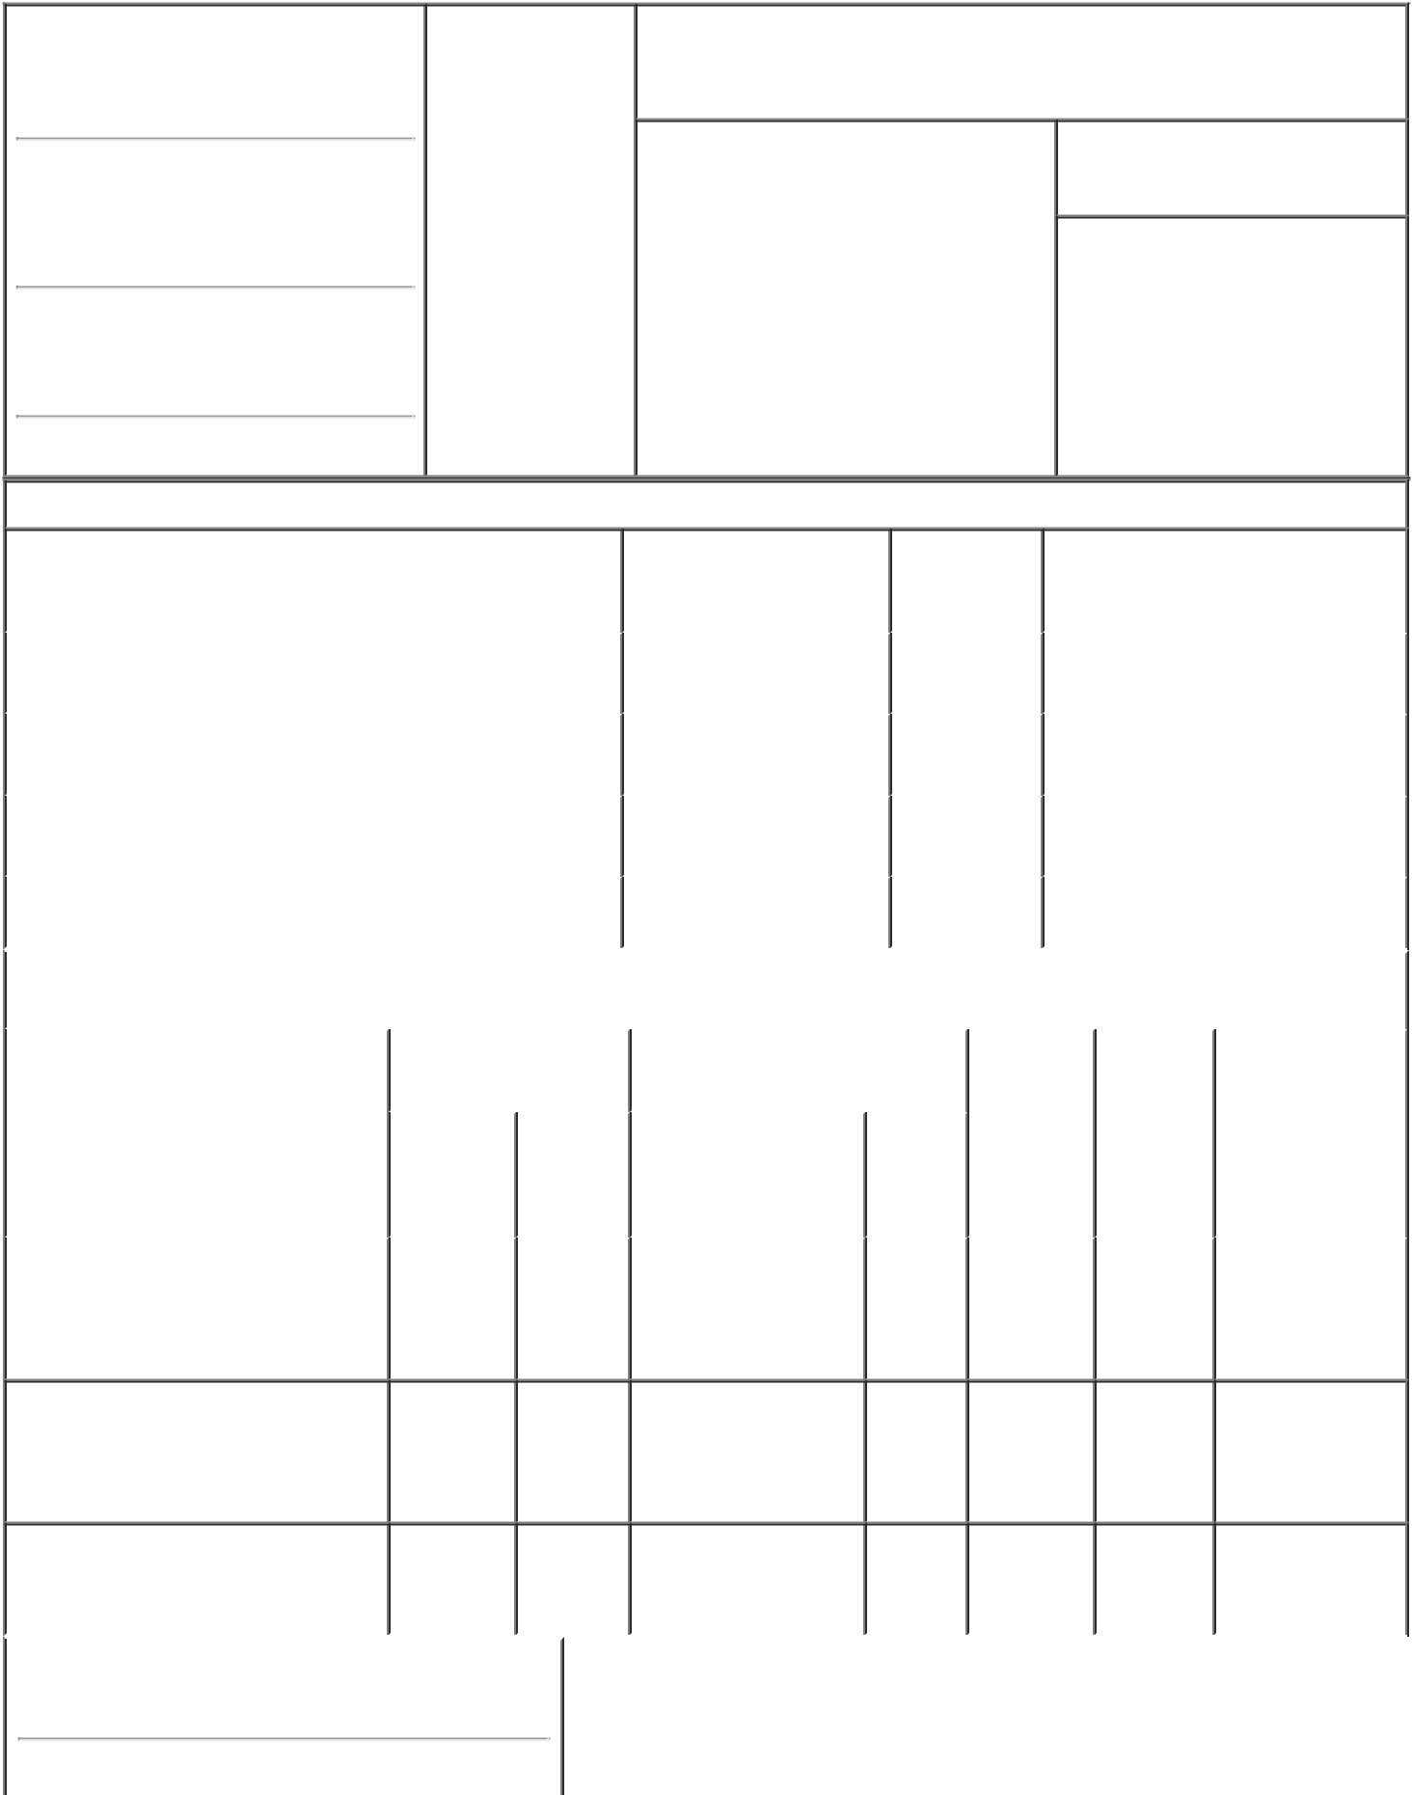

1. Name and Address of Reporting Person |  |  | * |  | 2. Date of Event
 |  |  |  |  | Requiring Statement
 | Atalaya Capital Management
 |  |  |  |  | (Month/Day/Year)
 | LP |  |  |  | 10/08/2021

3. Issuer Name and Ticker or Trading Symbol

Live Oak Acquisition Corp II [ LOKB ]

(Last) (First) (Middle)

ONE ROCKEFELLER PLAZA, 32ND FLOOR

(Street)

^{NEW} NY 10020 YORK

- Relationship of Reporting Person(s) to Issuer
(Check all applicable)

Director X 10% Owner

Officer (give Other (specify
title below) below)

- If Amendment, Date of Original Filed (Month/Day/Year)

- Individual or Joint/Group Filing (Check Applicable Line)

Form filed by One Reporting Person

- Form filed by More than One Reporting Person

(City) (State) (Zip)

Table I - Non-Derivative Securities Beneficially Owned

 | 1. Title of Security (Instr. 4) |  |  |  | 2. Amount of Securities | 3. Ownership |  |  | 4. Nature of Indirect Beneficial
 |  |  |  |  | Beneficially Owned (Instr. | Form: Direct |  |  | Ownership (Instr. 5)
 |  |  |  |  | 4) | (D) or Indirect
 |  |  |  |  |  | (I) (Instr. 5)
 | Class A Common Stock |  |  |  | 445,040 |  | I |  | By Atalaya Special Purpose
 |  |  |  |  |  |  |  |  | Investment Fund LP⁽¹⁾
 | Class A Common Stock |  |  |  | 1,360,949 |  | I |  | By ACM ASOF VII (Cayman)
 |  |  |  |  |  |  |  |  | Holdco LP⁽²⁾
 | Class A Common Stock |  |  |  | 953,333 |  | I |  | By Corbin ERISA Opportunity
 |  |  |  |  |  |  |  |  | Fund, Ltd.⁽³⁾
 | Class A Common Stock |  |  |  | 476,667 |  | I |  | By Corbin Opportunity Fund, L.P.
 |  |  |  |  |  |  |  |  | (3)
 |  |  | Table II - Derivative Securities Beneficially Owned
 |  | (e.g., puts, calls, warrants, options, convertible securities)
 | 1. Title of Derivative Security (Instr. 4) |  | 2. Date Exercisable and |  | 3. Title and Amount of Securities |  | 4. |  |  | 5. | 6. Nature of
 |  |  | Expiration Date |  | Underlying Derivative Security |  |  | Conversion |  | Ownership | Indirect Beneficial
 |  |  | (Month/Day/Year) |  | (Instr. 4) |  |  | or Exercise |  | Form: | Ownership (Instr.
 |  |  |  |  |  |  |  | Price of |  | Direct (D) | 5)
 |  |  |  |  |  | Amount
 |  |  |  |  |  |  |  | Derivative |  | or Indirect
 |  |  |  |  |  | or |  | Security |  | (I) (Instr. 5)
 |  |  |  |  |  | Number
 |  |  | Date | Expiration |  | of
 |  |  | Exercisable | Date | Title | Shares

Warrants

Warrants

 |  |  |  |  |  | By Atalaya
(4) | (4) | Class A Common | 73,333 | 11.5 | I | Special Purpose
 |  | Stock |  |  |  | Investment Fund
 |  |  |  |  |  | _{LP}(1)
 |  |  |  |  |  | By Corbin
(4) | (4) | Class A Common | 317,777 | 11.5 | I | ERISA
 |  | Stock |  |  |  | Opportunity
Fund, Ltd.⁽³⁾

 |  |  |  | Class A Common |  |  |  | By Corbin
 | Warrants | (4) | (4) |  | 158,889 | 11.5 | I | Opportunity
 |  |  |  | Stock
 |  |  |  |  |  |  |  | Fund, L.P.⁽³⁾

1. Name and Address of Reporting Person*
Atalaya Capital Management LP

(Last) (First) (Middle)

ONE ROCKEFELLER PLAZA, 32ND FLOOR

(Street)
 | NEW YORK | NY | 10020
 | (City) | (State) | (Zip)

1. Name and Address of Reporting Person*
ACM ASOF VII (Cayman) Holdco LP

(Last) (First) (Middle)

ONE ROCKEFELLER PLAZA, 32ND FLOOR

(Street)
 | NEW YORK | NY | 10022
 | (City) | (State) | (Zip)

Explanation of Responses:

- Atalaya Capital Management LP (ACM) is the investment manager of Atalaya Special Purpose Investment Fund LP (ASPIF). ACM disclaims beneficial ownership over the securities held of record by ASPIF except to the extent of its pecuniary interest therein, if any.

- ACM is the investment manager of ACM ASOF VII (Cayman) Holdco LP (ASOF). ACM disclaims beneficial ownership over the securities held of record by ASOF except to the extent of its pecuniary interest therein, if any.

- ACM serves as sub-advisor to Corbin ERISA Opportunity Fund, Ltd. (CEOF) and Corbin Opportunity Fund, L.P. (COF), and in such capacity, may be deemed to have beneficial ownership over the securities held directly by CEOF and COF. ACM disclaims beneficial ownership over the securities held of record by CEOF and COF except to the extent of its pecuniary interest therein, if any.

- The warrants will become exercisable commencing on the later of 12 months from the closing of the Issuers initial public offering or 30 days after the completion of the Issuers initial business combination, and will expire five years after the completion of the Issuers initial business combination or earlier upon redemption or liquidation.

Atalaya Capital
Management LP By: /s/ |  |  |  |  |  |  |  |  |  |  | 10/13/2021
Drew Phillips, Authorized
Signatory
ACM ASOF VII
(Cayman) Holdco LP By:
Atalaya Capital
Management LP, its |  |  |  |  |  |  |  |  |  |  | 10/13/2021
investment manager By:
/s/ Drew Phillips,
Authorized Signatory

** Signature of Reporting | Date
Person
Reminder: Report on a separate line for each class of securities beneficially owned directly or indirectly.
* If the form is filed by more than one reporting person, see Instruction 5 (b)(v).

- Intentional misstatements or omissions of facts constitute Federal Criminal Violations See 18 U.S.C. 1001 and 15 U.S.C. 78ff(a). Note: File three copies of this Form, one of which must be manually signed. If space is insufficient, see Instruction 6 for procedure.
Persons who respond to the collection of information contained in this form are not required to respond unless the form displays a currently valid OMB Number.

