UNITED STATES
SECURITIES AND EXCHANGE COMMISSION
Washington, D.C. 20549

FORM 8-K

CURRENT REPORT
Pursuant to Section 13 or 15(d) of the Securities Exchange Act of 1934

Date of Report (Date of earliest event reported): July 27, 2026



Navitas Semiconductor Corporation
(Exact name of registrant as specified in its charter)

Delaware |  |  |  |  |  | 001-39755 |  |  |  |  |  | 85-2560226
(State or other jurisdiction |  |  |  |  |  | (Commission File Number) |  |  |  |  |  | (IRS Employer Identification No.)
of incorporation)

3520 Challenger Street, |  |  | Torrance, |  |  | California |  |  |  |  |  | 90503-1640
(Address of principal executive offices) |  |  |  |  |  |  |  |  |  |  |  | (Zip Code)

Registrant’s telephone number, including area code: (844) 654-2642

Check the appropriate box below if the Form 8-K filing is intended to simultaneously satisfy the filing obligations of the registrant under any of the following provisions:

☐ |  |  |  |  |  | Written communications pursuant to Rule 425 under the Securities Act (17 CFR 230.425)
☐ |  |  |  |  |  | Soliciting material pursuant to Rule 14a-12 under the Exchange Act (17 CFR 240.14a-12)
☐ |  |  |  |  |  | Pre-commencement communications pursuant to Rule 14d-2(b) under the Exchange Act (17 CFR 240.14d-2(b))
☐ |  |  |  |  |  | Pre-commencement communications pursuant to Rule 13e-4(c) under the Exchange Act (17 CFR 240.13e-4(c))

Securities registered pursuant to Section 12(b) of the Act:
Title of each class |  |  | Trading Symbol(s) |  |  | Name of each exchange on which registered
Class A Common Stock,  par value $0.0001 per share |  |  | NVTS |  |  | The Nasdaq Stock Market LLC
Indicate by check mark whether the registrant is an emerging growth company as defined in Rule 405 of the Securities Act of 1933 (§230.405 of this chapter) or Rule 12b-2 of the Securities Exchange Act of 1934 (§240.12b-2 of this chapter).
Emerging growth company ☐

If an emerging growth company, indicate by check mark if the registrant has elected not to use the extended transition period for complying with any new or revised financial accounting standards provided pursuant to Section 13(a) of the Exchange Act. ☐

Item 2.02. Results of Operations and Financial Condition.

On July 27, 2026, Navitas Semiconductor Corporation issued a press release announcing its unaudited consolidated financial results for the quarterly period ended June 30, 2026. The press release is furnished as Exhibit 99.1 to this report and is incorporated by reference herein.

Item 7.01. Regulation FD Disclosure.

On July 27, 2026, Navitas Semiconductor Corporation issued its 2Q26 earnings call presentation, which is attached as Exhibit 99.2 to this report and is incorporated by reference herein.

The information provided under Items 2.02 and 7.01 of this Form 8-K, including Exhibits 99.1 and 99.2, is being furnished and shall not be considered “filed” for purposes of Section 18 of the Securities Exchange Act of 1934, nor subject to the liabilities of that section. In addition, such information and exhibits shall not be deemed incorporated by reference into any of the Company’s filings under the Securities Act of 1933, as amended, unless specifically stated otherwise.

Item 9.01. Financial Statements and Exhibits.
(d) Exhibits.

Exhibit  Number |  |  | Description
99.1 |  |  | Press release, dated July 27, 2026
99.2 |  |  | Navitas 2Q26 earnings call presentation, dated July 27, 2026
104 |  |  | Cover Page Interactive Data File (embedded within the Inline XBRL document)

SIGNATURES

Pursuant to the requirements of the Securities Exchange Act of 1934, the registrant has duly caused this report to be signed on its behalf by the undersigned hereunto duly authorized.
 |  |  |  |  |  | NAVITAS SEMICONDUCTOR CORPORATION
Dated: July 27, 2026
 |  |  |  |  |  | By: |  |  | /s/ Chris Allexandre
 |  |  |  |  |  |  |  |  | Chris Allexandre
 |  |  |  |  |  |  |  |  | President and Chief Executive Officer

Exhibit 99.1
Navitas Semiconductor Announces Second Quarter 2026 Financial Results

•Total revenue grew 22% sequentially with high-power markets growing more than 50% year-over-year and driving expanded gross margin
•Revenue growth expected to accelerate in the third quarter, with the mid-point of guidance representing sequential growth of 28% coupled with further margin expansion
•Strong backlog and demand support continued double-digit growth in the fourth quarter, contributing to anticipated achievement of mid-single-digit revenue growth for the full year, while simultaneously having substantially exited the mobile market and completing the Navitas 2.0 transition to a high-power company
•Growth increasingly driven by AI Infrastructure markets, including AI Data Centers and Grid and Energy Infrastructure, which will represent more than one-third of total sales by year end and generate strong momentum into 2027

TORRANCE, Calif., July 27, 2026 – Navitas Semiconductor, (Nasdaq: NVTS), an industry leader in next-generation GaNFast™ gallium nitride (GaN) and GeneSiC™ silicon carbide (SiC) power semiconductors, today announced unaudited financial results for its second quarter 2026 ended June 30, 2026.

“Our strong second quarter results and expectations for continued double-digit quarterly growth in the second half of the year demonstrate the increasing traction of our strategic shift to Navitas 2.0 and focus exclusively on high-power markets,” stated Chris Allexandre, President and CEO of Navitas. “With the rapid adoption of AI, we are seeing accelerated market demand to overcome critical power bottlenecks in AI infrastructure, both within AI data centers as well as the requisite grid and energy infrastructure needed to power them. By the end of the year, Navitas will complete its transition with revenue from mobile and low-end consumer being insignificant and nearly all sales coming from high-power markets.

“Underpinning our growing momentum is Navitas’ unique ability to deliver high-power products with both GaN and high-voltage SiC technologies, enabling the distinct power requirements across AI infrastructure applications. We are seeing an expanding backlog, record level book-to-bill, and shipping volume production samples of our GaN and SiC-based solutions in support of multiple customer new program ramps. These production samples across GaN, HV SiC and UHV SiC include shipments in support of existing customer engagements for next-generation AI data centers targeting 800 V architectures. We expect selected hyperscalers and XPU platforms to ramp in 2027 as well as accelerated uptake of new grid infrastructure products. As we execute toward a series of inflection points that will drive explosive GaN and SiC content growth in years to come, we are confident in Navitas’ ability to capitalize on the substantial and growing market opportunity for high-power solutions.”

Commenting on the results, Tonya Stevens, CFO of Navitas, stated, “Our second quarter results reflect the Company’s continued strong momentum and growth in high-power markets with total revenue growing 22% sequentially to $10.5 million, and gross margin expanding 50 basis points on a non-GAAP basis. Additionally, we capitalized on the opportunity to further strengthen the balance sheet – ending the quarter with $557 million in cash, increasing our flexibility to make focused strategic investments in our portfolio and capacity expansion as well as support accelerated market penetration across AI infrastructure. We expect to deliver continued double-digit sequential growth in the third quarter, which will also represent a return to year-over-year revenue growth as well as position the Company to achieve mid-single-digit revenue growth for the full year, highlighting the completed transformation to Navitas 2.0 as a high-power company.”

Second Quarter 2026 Financial Highlights
•Revenue: Total revenue was $10.5 million in the second quarter of 2026, compared to $8.6 million in the first quarter of 2026 and $14.5 million in the second quarter of 2025.
•Gross Margin: GAAP gross margin for the quarter was 0.4%, compared to (9.3%) in the first quarter of 2026 and (11.8%) in the second quarter of 2025. GAAP gross margin for the current and prior periods includes approximately $4 million of cost associated with amortization of intangibles. On a non-GAAP basis, gross margin for the quarter was 39.5% compared to 39.0% in the prior quarter and 38.5% in the second quarter of 2025.
•Results from Operations: GAAP loss from operations for the quarter was $27.2 million, compared to a loss of $27.8 million for the first quarter of 2026 and an operating loss of $21.7 million for the second quarter of 2025. On a non-GAAP basis, loss from operations for the quarter was $11.4 million compared to a loss of $11.7 million for the prior quarter and a loss of $10.6 million in the second quarter of 2025.
•Net Results: GAAP net loss was $228.2 million in the second quarter of 2026, which included a non-cash charge of $203.1 million from the final remeasurement of earnout liabilities, compared to a net loss of $33.8 million in the first quarter of 2026 and a net loss of $49.1 million in the second quarter of 2025. On a non-GAAP basis, net loss for the quarter was $9.3 million, compared to a net loss of $9.8 million for the prior quarter and a net loss of $9.8 million in the second quarter of 2025.
•Cash: Cash and cash equivalents were $557.4 million as of June 30, 2026, compared to $236.9 million as of December 31, 2025.

Recent Business, Customer and Technology Highlights:
•Introduced breakthrough Isolated TO product family purpose-built for 1.2 kV to 3.3 kV SiC MOSFETs, enabling direct-cooled thermal management and delivering module-like performance in a compact discrete form factor.
•Expanded existing SiC portfolio with newly introduced 1.2 kV JFET product line, to be released by early 2027 – initially targeting AI data centers, solid-state transformer and energy grid infrastructure applications, which are estimated to represent an incremental $1 billion SAM.
•Deepened collaboration with NVIDIA MGX™ Ecosystem in support of accelerating 800 V DC rack architectures for next-generation AI data centers with demonstration of 800 V-to-6 V DC-DC power delivery board at COMPUTEX 2026.

•Continued advancement of growing engagements for both SiC and GaN-based high-power solutions in support of numerous customers’ design programs and architectures across AI Infrastructure, including next-generation applications in AI Data Centers and Grid and Energy Infrastructure.

Third Quarter 2026 Business Outlook
•Third quarter 2026 net revenues are expected to increase to $13.5 million, plus or minus $0.5 million, which at the midpoint represents 28% sequential growth and would mark a return to year-over-year growth. Non-GAAP gross margin is expected to be 39.7%, plus or minus 100 basis points, which at midpoint represents a 20 basis point increase, and non-GAAP operating expenses are expected to be in a range between $15.5 and $17.5 million.
A reconciliation of our forward-looking non-GAAP gross margin and non-GAAP operating expenses to the most directly comparable GAAP measures is not provided because such items cannot be reasonably calculated without unreasonable efforts due to the unpredictability of the amounts and
timing of events affecting the items we exclude, including stock-based compensation expense and restructuring charges.

Second Quarter 2026 Financial Results Conference Call and Webcast Information:

•When: Monday, July 27, 2026
•Time: 2:00 p.m. Pacific Time (5:00 p.m. Eastern Time)
•Toll Free Dial-in: 1-800-715-9871 or 1-646-307-1963
•Conference ID: 1184638
•Webcast: https://edge.media-server.com/mmc/p/2navqzm3

Additionally, a live and archived audio webcast of the conference call as well as supporting presentation materials will be accessible from the Investor Relations section of the Company’s website at ir.navitassemi.com.

Non-GAAP Financial Measures
This press release and statements in our public webcast include financial measures that are not calculated in accordance with generally accepted accounting principles (“GAAP”), which we refer to as “non-GAAP financial measures,” including (i) non-GAAP gross profit, (ii) non-GAAP gross margin, (iii) non-GAAP operating expense, (iv) non-GAAP research and development expense, (v) non-GAAP selling, general and administrative expense, (vi) non-GAAP loss from operations, (vii) non-GAAP operating margin, and (viii) non-GAAP net loss and net loss per share. Each of these non-GAAP financial measures is adjusted from GAAP results to exclude certain items, which for the periods presented include stock-based compensation and associated employer payroll taxes; amortization of acquisition-related intangible assets; changes in the fair value of earnout liabilities; restructuring and impairment charges; legal and related professional fees associated with matters that are extraordinary, non-recurring, or outside the ordinary course of business; equity method investment losses or gains; and certain other items identified in the “Reconciliation of GAAP Results to Non-GAAP Financial Measures” tables below. These items are generally non-cash in nature, relate to discrete events or activities, or vary in amount and frequency for reasons independent of our underlying operating performance. We believe these non-GAAP financial measures provide investors with useful supplemental information about our operating performance and enable comparison of financial trends and results between periods where certain items may vary independently of business performance. We believe these non-GAAP financial measures offer an additional view of our operations that, when coupled with the GAAP results and the reconciliations from corresponding GAAP financial measures, provide a more complete understanding of the results of operations. However, these non-GAAP financial measures should be considered as a supplement to, and not as a substitute for, or superior to, the corresponding measures calculated in accordance with GAAP.

Cautionary Statement Regarding Forward-Looking Statements
This press release, including the paragraph headed “Third Quarter 2026 Business Outlook,” includes “forward-looking statements” within the meaning of Section 21E of the Securities Exchange Act of 1934, as amended. Forward-looking statements are attempts to predict or indicate future events or trends or similar statements that are not a reflection of historical fact. Forward-looking statements may be identified by the use of words such as “we expect” or “are expected to be,” “estimate,” “plan,” “project,” “forecast,” “intend,” “anticipate,” “believe,” “seek,” or other similar expressions. Forward-looking statements are made based on estimates and forecasts of financial and performance metrics, projections of market opportunity and market share and current indications of customer interest, all of
which are based on various assumptions, whether or not identified in this press release. All such statements are based on current expectations of the management of Navitas and are not predictions of actual future performance. Forward-looking statements are provided for illustrative purposes only and are not intended to serve as, and must not be relied on by any investor as, a guarantee, an assurance, a prediction or a definitive statement of fact or probability. Actual events and circumstances are difficult or impossible to predict and will differ from assumptions and expectations. Many actual events and circumstances that affect performance are beyond the control of Navitas, and forward-looking statements are subject to a number of uncertainties.

Our business is subject to certain risks that could materially and adversely affect our business, financial condition, results of operations, or the value of our securities. These and other risk factors are discussed in the Risk Factors section of our most recent annual report on Form 10-K, as updated in the Risk Factors section of our most recent quarterly report on Form 10-Q, and in other documents we file with the SEC. If any of these risks, as discussed in more detail in our SEC reports, materialize or if our assumptions underlying forward-looking statements prove to be incorrect, actual results could differ materially from the results implied by these forward-looking statements. Examples of some of these risk factors include:

•Risks Related to High-Power Markets: Last year, we announced an enhanced focus on AI data centers, energy and grid infrastructure, performance computing and industrial electrification, and a de-emphasis on mobile and consumer products. We may not successfully execute our strategic transition to these new markets and customer applications, which could adversely affect our business, results of operations, and financial condition. This strategic realignment entails significant operational, technical, and market risks. Our success in these markets depends on factors including our ability to (i) develop and scale semiconductor solutions that meet demanding power, efficiency, and performance requirements of our customers; (ii) compete against established incumbents with substantial R&D and manufacturing resources; (iii) anticipate rapidly evolving customer needs and technological standards in these high-power and high-performance segments; and (iv) secure design wins and long-term supply agreements in new and unfamiliar market segments.
•Market Acceptance and Addressable Market Uncertainty: The demand for our products, and our customers’ products, in new or emerging markets is difficult to forecast, as customer preferences may not be fully known and can evolve rapidly. Further, demand for our products depends on the acceptance of underlying new and developing system architectures. For example, our predictions for the use of GaN- and SiC-based products in 800 V AI data center power applications depend on assumptions regarding the acceptance and growth of 800 V systems themselves. Our forecasts are based on market opportunities across a “Serviceable Addressable Market” or “SAM”, which is based on a number of assumptions and predictions. We could be wrong about the size or timing of our SAM, which could in turn diminish the market opportunities available to us.
•Unpredictable Historical Data and Competitive Dynamics: In established markets, revenue projections can be supported by trends from prior periods. In contrast, there is little or no precedent for products aimed at new use cases, rendering traditional forecasting methods less reliable. To the extent our products reshape or create new market landscapes, the competitive environment may evolve in unexpected ways. For example, new competitors may emerge, or traditional competitors with established R&D and manufacturing resources, and long-standing customer relationships, may choose to offer competitive GaN or high-voltage SiC solutions.
•Other Risk Factors: Other risk factors related to our business include our ability to achieve design wins and to convince our current and prospective end customers to design our products into their product offerings, the risk that revenues from design wins may not materialize, the possibility that we may fail to accurately anticipate and respond to rapid technological change in
the industries in which we operate or adapt to emerging industry standards, our dependence on a few key customers and distributors for a significant portion of our revenue, and the fact our business is subject to volatile demand and seasonal fluctuations. In addition, our supply chain is also subject to risks, including our reliance on single sources of supply for certain essential services, the risk that our suppliers may have quality, yield or capacity issues, the fact that we are exposed to fluctuations in prices for raw materials and components, and the risk that our products will not meet the reliability standards expected of high-power semiconductor devices.

This is not a summary of all of the risks that could affect our business and you are encouraged to review the full list of risk factors in our SEC filings.

Note Regarding Customer Pipeline and Design Wins
In our investor and other communications we may refer to the terms “customer pipeline” and “design wins” in discussions of potential future business opportunities. Each of these terms, together with information we may disclose about anticipated future business in relation to these terms, constitutes “forward-looking statements” as described above and, accordingly, should be interpreted in light of related risks which, if materialized, could cause actual results to differ materially from those indicated from our view of customer pipeline and design wins today. More specifically, “customer pipeline” reflects estimated potential future business based on interest expressed by potential customers for qualified programs, stated in terms of estimated revenue that may be realized over the life of the customer’s end product. A “design win” reflects an end customer’s selection of a Navitas product for a specific production program, stated in terms of revenues that may be realized over the life of the customer’s end product. However, customer pipeline figures and design wins do not represent customer orders or forecasts, are not proxies for backlog or estimates of future revenue, and should not be considered as any other measure or indicator of financial performance. Rather, Navitas uses these terms to indicate the company’s current view of future potential business and related changes across various end markets. Time horizons vary based on product type and application. As a result, actual business realized will depend on several factors, including (i) whether potential customers ultimately choose the Navitas solution, (ii) the portion of the customer program awarded to the Navitas solution as compared to other sources in dual- or multiple-source cases, (iii) successful customer qualification of the selected solution, (iv) the time needed for customers to begin mass production, (v) the duration and pace of the customer’s ramp to full production, and (vi) strategic decisions of Navitas throughout the process based on expected revenues, margins and other factors relating to pipeline opportunities and design wins.

About Navitas
Navitas Semiconductor (Nasdaq: NVTS) is a next-generation power semiconductor leader in gallium nitride (GaN) and IC integrated devices, and high-voltage silicon carbide (SiC) technology, driving innovation across AI data centers, energy and grid infrastructure, performance computing and industrial electrification. With more than 30 years of combined expertise in wide-bandgap technologies, GaNFast™ power ICs integrate GaN power, drive, control, sensing, and protection, delivering faster power delivery, higher system density, and greater efficiency. GeneSiC™ high-voltage SiC devices leverage patented trench-assisted planar technology to provide industry-leading voltage capability, efficiency, and reliability for medium-voltage grid and infrastructure applications. Navitas has over 300 patents issued or pending and is the world’s first semiconductor company to be CarbonNeutral®-certified.
Navitas Semiconductor, GaNFast, GaNSense, GeneSiC, and the Navitas logo are trademarks or registered trademarks of Navitas Semiconductor Limited and affiliates. All other brands, product names, and marks are or may be trademarks or registered trademarks used to identify products or services of their respective owners.

Investor Relations Contacts:
Shelton Group
Leanne Sievers | Brett Perry
nvts-ir@sheltongroup.com

NAVITAS SEMICONDUCTOR CORPORATION
CONDENSED CONSOLIDATED STATEMENTS OF OPERATIONS (GAAP) - UNAUDITED
(dollars in thousands, except per share amounts)
 |  |  |  |  |  | Three Months Ended June 30, |  |  |  |  |  |  |  |  |  |  |  | Six Months Ended June 30,
 |  |  |  |  |  | 2026 |  |  |  |  |  | 2025 |  |  |  |  |  | 2026 |  |  |  |  |  | 2025
Net revenues |  |  |  |  |  | $ | 10,529 |  |  |  |  | $ | 14,490 |  |  |  |  | $ | 19,127 |  |  |  |  | $ | 28,508
Cost of revenues (exclusive of amortization of intangible assets included below) |  |  |  |  |  | 6,451 |  |  |  |  |  | 12,162 |  |  |  |  |  | 11,813 |  |  |  |  |  | 20,873
Operating expenses:
Research and development |  |  |  |  |  | 13,152 |  |  |  |  |  | 11,496 |  |  |  |  |  | 27,719 |  |  |  |  |  | 24,164
Selling, general and administrative |  |  |  |  |  | 13,038 |  |  |  |  |  | 7,751 |  |  |  |  |  | 24,290 |  |  |  |  |  | 19,491
Amortization of intangible assets |  |  |  |  |  | 4,734 |  |  |  |  |  | 4,734 |  |  |  |  |  | 9,468 |  |  |  |  |  | 9,468
Restructuring expense |  |  |  |  |  | 344 |  |  |  |  |  | — |  |  |  |  |  | 794 |  |  |  |  |  | 1,469
Total operating expenses |  |  |  |  |  | 31,268 |  |  |  |  |  | 23,981 |  |  |  |  |  | 62,271 |  |  |  |  |  | 54,592
Loss from operations |  |  |  |  |  | (27,190) |  |  |  |  |  | (21,653) |  |  |  |  |  | (54,957) |  |  |  |  |  | (46,957)
Other income (expense), net:
Interest income (expense), net |  |  |  |  |  | 274 |  |  |  |  |  | 131 |  |  |  |  |  | 538 |  |  |  |  |  | 93
Dividend income |  |  |  |  |  | 1,827 |  |  |  |  |  | 647 |  |  |  |  |  | 3,515 |  |  |  |  |  | 1,391
Loss from change in fair value of earnout liabilities |  |  |  |  |  | (203,068) |  |  |  |  |  | (27,964) |  |  |  |  |  | (210,981) |  |  |  |  |  | (19,851)
Other income |  |  |  |  |  | 10 |  |  |  |  |  | 37 |  |  |  |  |  | 20 |  |  |  |  |  | 55
Total other income (expense), net |  |  |  |  |  | (200,957) |  |  |  |  |  | (27,149) |  |  |  |  |  | (206,908) |  |  |  |  |  | (18,312)
Loss before income taxes |  |  |  |  |  | (228,147) |  |  |  |  |  | (48,802) |  |  |  |  |  | (261,865) |  |  |  |  |  | (65,269)
Income tax provision |  |  |  |  |  | 71 |  |  |  |  |  | 48 |  |  |  |  |  | 138 |  |  |  |  |  | 130
Equity method investment loss |  |  |  |  |  | — |  |  |  |  |  | (225) |  |  |  |  |  | — |  |  |  |  |  | (505)
Net loss |  |  |  |  |  | $ | (228,218) |  |  |  |  | $ | (49,075) |  |  |  |  | $ | (262,003) |  |  |  |  | $ | (65,904)
Net loss per common share
Basic |  |  |  |  |  | $ | (0.95) |  |  |  |  | $ | (0.25) |  |  |  |  | $ | (1.11) |  |  |  |  | $ | (0.34)
Diluted |  |  |  |  |  | $ | (0.95) |  |  |  |  | $ | (0.25) |  |  |  |  | $ | (1.11) |  |  |  |  | $ | (0.34)
Shares used in per share calculation:
Basic |  |  |  |  |  | 240,643 |  |  |  |  |  | 198,956 |  |  |  |  |  | 235,874 |  |  |  |  |  | 193,462
Diluted |  |  |  |  |  | 240,643 |  |  |  |  |  | 198,956 |  |  |  |  |  | 235,874 |  |  |  |  |  | 193,462

NAVITAS SEMICONDUCTOR CORPORATION
RECONCILIATION OF GAAP RESULTS TO NON-GAAP FINANCIAL MEASURES - UNAUDITED
(dollars in thousands, except per share amounts)
 |  |  |  |  |  | Three Months Ended June 30, |  |  |  |  |  |  |  |  |  |  |  | Six Months Ended June 30,
 |  |  |  |  |  | 2026 |  |  |  |  |  | 2025 |  |  |  |  |  | 2026 |  |  |  |  |  | 2025
RECONCILIATION OF GROSS PROFIT MARGIN
GAAP Net revenues |  |  |  |  |  | $ | 10,529 |  |  |  |  | $ | 14,490 |  |  |  |  | $ | 19,127 |  |  |  |  | $ | 28,508
Cost of revenues (exclusive of amortization of intangibles) |  |  |  |  |  | (6,451) |  |  |  |  |  | (12,162) |  |  |  |  |  | (11,813) |  |  |  |  |  | (20,873)
Cost of revenues (amortization of intangibles) |  |  |  |  |  | (4,037) |  |  |  |  |  | (4,035) |  |  |  |  |  | (8,073) |  |  |  |  |  | (8,067)
GAAP Gross profit |  |  |  |  |  | 41 |  |  |  |  |  | (1,707) |  |  |  |  |  | (759) |  |  |  |  |  | (432)
GAAP Gross margin |  |  |  |  |  | 0.4 |  | % |  |  |  | (11.8) |  | % |  |  |  | (4.0) |  | % |  |  |  | (1.5) |  | %
Cost of revenues (amortization of intangibles) |  |  |  |  |  | 4,037 |  |  |  |  |  | 4,035 |  |  |  |  |  | 8,073 |  |  |  |  |  | 8,067
China SiC inventory reserve |  |  |  |  |  | — |  |  |  |  |  | 3,174 |  |  |  |  |  | — |  |  |  |  |  | 3,174
Stock-based compensation expense |  |  |  |  |  | 82 |  |  |  |  |  | 71 |  |  |  |  |  | 200 |  |  |  |  |  | 107
Non-GAAP Gross profit |  |  |  |  |  | $ | 4,160 |  |  |  |  | $ | 5,573 |  |  |  |  | $ | 7,514 |  |  |  |  | $ | 10,916
Non-GAAP Gross margin |  |  |  |  |  | 39.5 |  | % |  |  |  | 38.5 |  | % |  |  |  | 39.3 |  | % |  |  |  | 38.3 |  | %
RECONCILIATION OF OPERATING EXPENSES
GAAP Research and development |  |  |  |  |  | $ | 13,152 |  |  |  |  | $ | 11,496 |  |  |  |  | $ | 27,719 |  |  |  |  | $ | 24,164
Advanced R&D NRE Impairment |  |  |  |  |  | — |  |  |  |  |  | (2,238) |  |  |  |  |  | — |  |  |  |  |  | (2,238)
Organization transformation costs |  |  |  |  |  | — |  |  |  |  |  | (395) |  |  |  |  |  | — |  |  |  |  |  | (395)
Stock-based compensation (expense) income 3 |  |  |  |  |  | (3,917) |  |  |  |  |  | 364 |  |  |  |  |  | (9,129) |  |  |  |  |  | (3,474)
Non-GAAP Research and development |  |  |  |  |  | 9,235 |  |  |  |  |  | 9,227 |  |  |  |  |  | 18,590 |  |  |  |  |  | 18,057
GAAP Selling, general and administrative |  |  |  |  |  | 13,038 |  |  |  |  |  | 7,751 |  |  |  |  |  | 24,290 |  |  |  |  |  | 19,491
Governance costs |  |  |  |  |  | — |  |  |  |  |  | (1,556) |  |  |  |  |  | — |  |  |  |  |  | (1,556)
Stock-based compensation (expense) income 3 |  |  |  |  |  | (4,386) |  |  |  |  |  | 620 |  |  |  |  |  | (9,395) |  |  |  |  |  | (2,478)
Other income (expense) 1 |  |  |  |  |  | (2,377) |  |  |  |  |  | 95 |  |  |  |  |  | (2,962) |  |  |  |  |  | (213)
Non-GAAP Selling, general and administrative |  |  |  |  |  | 6,275 |  |  |  |  |  | 6,910 |  |  |  |  |  | 11,933 |  |  |  |  |  | 15,244
Total Non-GAAP Operating expenses |  |  |  |  |  | $ | 15,510 |  |  |  |  | $ | 16,137 |  |  |  |  | $ | 30,523 |  |  |  |  | $ | 33,301
RECONCILIATION OF LOSS FROM OPERATIONS
GAAP Loss from operations |  |  |  |  |  | $ | (27,190) |  |  |  |  | $ | (21,653) |  |  |  |  | $ | (54,957) |  |  |  |  | $ | (46,957)
GAAP Operating margin |  |  |  |  |  | (258.2)% |  |  |  |  |  | (149.4)% |  |  |  |  |  | (287.3)% |  |  |  |  |  | (164.7)%
Add: Stock-based compensation expense (income) 3 included in:
Research and development |  |  |  |  |  | 3,917 |  |  |  |  |  | (364) |  |  |  |  |  | 9,129 |  |  |  |  |  | 3,474
Selling, general and administrative |  |  |  |  |  | 4,386 |  |  |  |  |  | (620) |  |  |  |  |  | 9,395 |  |  |  |  |  | 2,478
Cost of goods sold |  |  |  |  |  | 82 |  |  |  |  |  | 71 |  |  |  |  |  | 200 |  |  |  |  |  | 107
Total |  |  |  |  |  | 8,385 |  |  |  |  |  | (913) |  |  |  |  |  | 18,724 |  |  |  |  |  | 6,059
Amortization of acquisition-related intangible assets |  |  |  |  |  | 4,734 |  |  |  |  |  | 4,734 |  |  |  |  |  | 9,468 |  |  |  |  |  | 9,468
China SiC inventory reserve |  |  |  |  |  | — |  |  |  |  |  | 3,174 |  |  |  |  |  | — |  |  |  |  |  | 3,174
Advanced R&D NRE Impairment |  |  |  |  |  | — |  |  |  |  |  | 2,238 |  |  |  |  |  | — |  |  |  |  |  | 2,238
Governance costs |  |  |  |  |  | — |  |  |  |  |  | 1,556 |  |  |  |  |  | — |  |  |  |  |  | 1,556
Organization transformation costs |  |  |  |  |  | — |  |  |  |  |  | 395 |  |  |  |  |  | — |  |  |  |  |  | 395
Restructuring, impairment and other expense (income) 2 |  |  |  |  |  | 2,721 |  |  |  |  |  | (95) |  |  |  |  |  | 3,756 |  |  |  |  |  | 1,682
Non-GAAP Loss from operations |  |  |  |  |  | $ | (11,351) |  |  |  |  | $ | (10,564) |  |  |  |  | $ | (23,009) |  |  |  |  | $ | (22,385)
Non-GAAP Operating margin |  |  |  |  |  | (107.8) |  | % |  |  |  | (72.9) |  | % |  |  |  | (120.3) |  | % |  |  |  | (78.5) |  | %
RECONCILIATION OF NET LOSS PER SHARE
GAAP Net loss |  |  |  |  |  | $ | (228,218) |  |  |  |  | $ | (49,075) |  |  |  |  | $ | (262,003) |  |  |  |  | $ | (65,904)
Adjustments to GAAP Net loss
Total stock-based compensation expense (income) 3 |  |  |  |  |  | 8,385 |  |  |  |  |  | (913) |  |  |  |  |  | 18,724 |  |  |  |  |  | 6,059
Loss from change in fair value of earnout liabilities |  |  |  |  |  | 203,068 |  |  |  |  |  | 27,964 |  |  |  |  |  | 210,981 |  |  |  |  |  | 19,851
Amortization of acquisition-related intangible assets |  |  |  |  |  | 4,734 |  |  |  |  |  | 4,734 |  |  |  |  |  | 9,468 |  |  |  |  |  | 9,468
Restructuring, impairment and other expense (income) 2 |  |  |  |  |  | 2,721 |  |  |  |  |  | (95) |  |  |  |  |  | 3,756 |  |  |  |  |  | 1,682
Equity method investment loss |  |  |  |  |  | — |  |  |  |  |  | 225 |  |  |  |  |  | — |  |  |  |  |  | 505
China SiC inventory reserve |  |  |  |  |  | — |  |  |  |  |  | 3,174 |  |  |  |  |  | — |  |  |  |  |  | 3,174
Advanced R&D NRE Impairment |  |  |  |  |  | — |  |  |  |  |  | 2,238 |  |  |  |  |  | — |  |  |  |  |  | 2,238
Governance costs |  |  |  |  |  | — |  |  |  |  |  | 1,556 |  |  |  |  |  | — |  |  |  |  |  | 1,556
Organization transformation costs |  |  |  |  |  | — |  |  |  |  |  | 395 |  |  |  |  |  | — |  |  |  |  |  | 395
Non-GAAP Net loss |  |  |  |  |  | $ | (9,311) |  |  |  |  | $ | (9,797) |  |  |  |  | $ | (19,074) |  |  |  |  | $ | (20,976)
Average shares outstanding for calculation of non-GAAP Net loss per share (basic and diluted) |  |  |  |  |  | 240,643 |  |  |  |  |  | 198,956 |  |  |  |  |  | 235,874 |  |  |  |  |  | 193,462
Non-GAAP Net loss per share (basic and diluted) |  |  |  |  |  | $ | (0.04) |  |  |  |  | $ | (0.05) |  |  |  |  | $ | (0.08) |  |  |  |  | $ | (0.11)
(1) Includes employer payroll taxes on stock-based compensation and legal and related professional fees associated with matters that are extraordinary, non-recurring, or outside the ordinary course of business.

(2) Includes restructuring and impairment charges and the other expense described in note (1).

(3) The 2025 periods include the reversal of stock-based compensation expense due to award forfeitures following an employee termination.

NAVITAS SEMICONDUCTOR CORPORATION
CONDENSED CONSOLIDATED BALANCE SHEETS - UNAUDITED
(dollars in thousands)
 |  |  |  |  |  | June 30, 2026 |  |  |  |  |  | December 31, 2025
ASSETS
Current assets
Cash and cash equivalents |  |  |  |  |  | $ | 557,409 |  |  |  |  | $ | 236,857
Accounts receivable, net |  |  |  |  |  | 4,767 |  |  |  |  |  | 3,621
Inventories |  |  |  |  |  | 19,510 |  |  |  |  |  | 13,283
Prepaid expenses and other current assets |  |  |  |  |  | 19,840 |  |  |  |  |  | 4,399
Restricted cash |  |  |  |  |  | 863 |  |  |  |  |  | 1,745
Total current assets |  |  |  |  |  | 602,389 |  |  |  |  |  | 259,905
Property and equipment, net |  |  |  |  |  | 8,570 |  |  |  |  |  | 9,779
Operating lease right of use assets |  |  |  |  |  | 4,109 |  |  |  |  |  | 5,166
Finance lease right of use assets |  |  |  |  |  | 602 |  |  |  |  |  | 766
Intangible assets, net |  |  |  |  |  | 43,790 |  |  |  |  |  | 53,258
Goodwill |  |  |  |  |  | 163,215 |  |  |  |  |  | 163,215
Other assets |  |  |  |  |  | 9,754 |  |  |  |  |  | 8,380
Total assets |  |  |  |  |  | $ | 832,429 |  |  |  |  | $ | 500,469
LIABILITIES AND STOCKHOLDERS’ EQUITY
Current liabilities
Accounts payable and other accrued expenses |  |  |  |  |  | $ | 19,506 |  |  |  |  | $ | 22,350
Accrued compensation expenses |  |  |  |  |  | 5,970 |  |  |  |  |  | 4,949
Operating lease liabilities, current |  |  |  |  |  | 1,835 |  |  |  |  |  | 1,866
Finance lease liabilities, current |  |  |  |  |  | 331 |  |  |  |  |  | 323
Earnout liability, current |  |  |  |  |  | — |  |  |  |  |  | 22,632
Total current liabilities |  |  |  |  |  | 27,642 |  |  |  |  |  | 52,120
Operating lease liabilities noncurrent |  |  |  |  |  | 2,681 |  |  |  |  |  | 3,827
Finance lease liabilities noncurrent |  |  |  |  |  | 289 |  |  |  |  |  | 456
Deferred tax liabilities |  |  |  |  |  | 405 |  |  |  |  |  | 405
Total liabilities |  |  |  |  |  | 31,017 |  |  |  |  |  | 56,808
Stockholders' equity |  |  |  |  |  | 801,412 |  |  |  |  |  | 443,661
Total liabilities and stockholders’ equity |  |  |  |  |  | $ | 832,429 |  |  |  |  | $ | 500,469

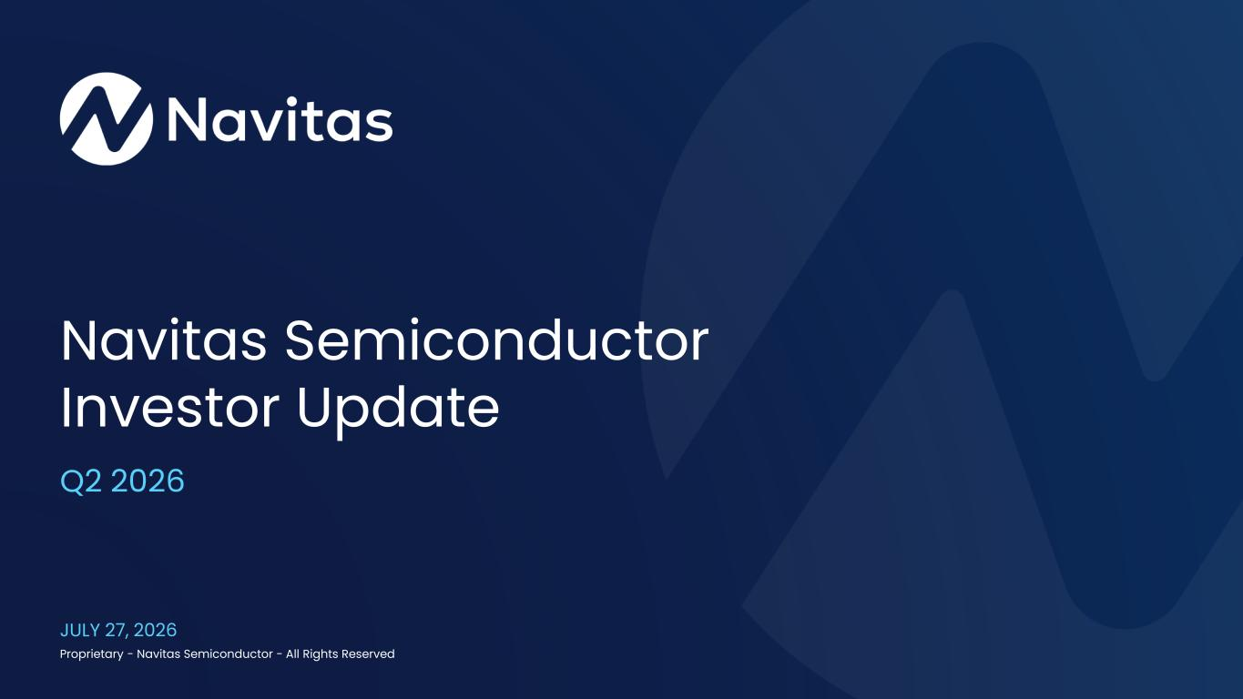

Proprietary - Navitas Semiconductor - All Rights Reserved Navitas Semiconductor Investor Update JULY 27, 2026 Q2 2026

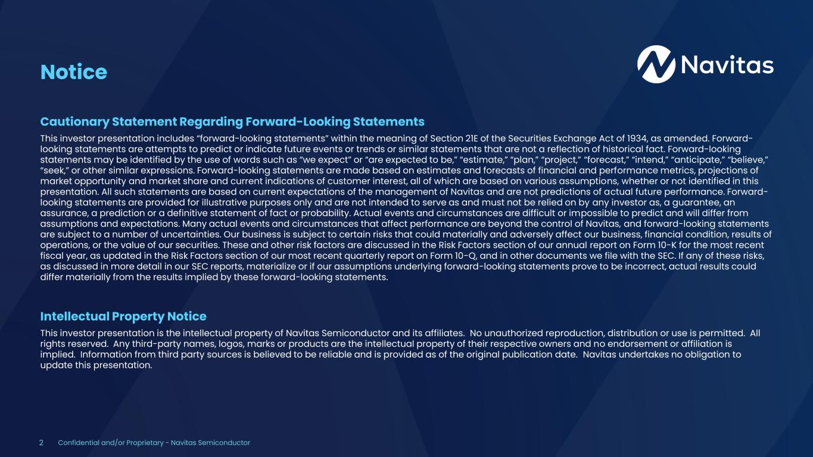
2 Confidential and/or Proprietary - Navitas Semiconductor Notice Cautionary Statement Regarding Forward-Looking Statements This investor presentation includes “forward-looking statements” within the meaning of Section 21E of the Securities Exchange Act of 1934, as amended. Forward- looking statements are attempts to predict or indicate future events or trends or similar statements that are not a reflection of historical fact. Forward-looking statements may be identified by the use of words such as “we expect” or “are expected to be,” “estimate,” “plan,” “project,” “forecast,” “intend,” “anticipate,” “believe,” “seek,” or other similar expressions. Forward-looking statements are made based on estimates and forecasts of financial and performance metrics, projections of market opportunity and market share and current indications of customer interest, all of which are based on various assumptions, whether or not identified in this presentation. All such statements are based on current expectations of the management of Navitas and are not predictions of actual future performance. Forward- looking statements are provided for illustrative purposes only and are not intended to serve as and must not be relied on by any investor as, a guarantee, an assurance, a prediction or a definitive statement of fact or probability. Actual events and circumstances are difficult or impossible to predict and will differ from assumptions and expectations. Many actual events and circumstances that affect performance are beyond the control of Navitas, and forward-looking statements are subject to a number of uncertainties. Our business is subject to certain risks that could materially and adversely affect our business, financial condition, results of operations, or the value of our securities. These and other risk factors are discussed in the Risk Factors section of our annual report on Form 10-K for the most recent fiscal year, as updated in the Risk Factors section of our most recent quarterly report on Form 10-Q, and in other documents we file with the SEC. If any of these risks, as discussed in more detail in our SEC reports, materialize or if our assumptions underlying forward-looking statements prove to be incorrect, actual results could differ materially from the results implied by these forward-looking statements. Intellectual Property Notice This investor presentation is the intellectual property of Navitas Semiconductor and its affiliates. No unauthorized reproduction, distribution or use is permitted. All rights reserved. Any third-party names, logos, marks or products are the intellectual property of their respective owners and no endorsement or affiliation is implied. Information from third party sources is believed to be reliable and is provided as of the original publication date. Navitas undertakes no obligation to update this presentation.

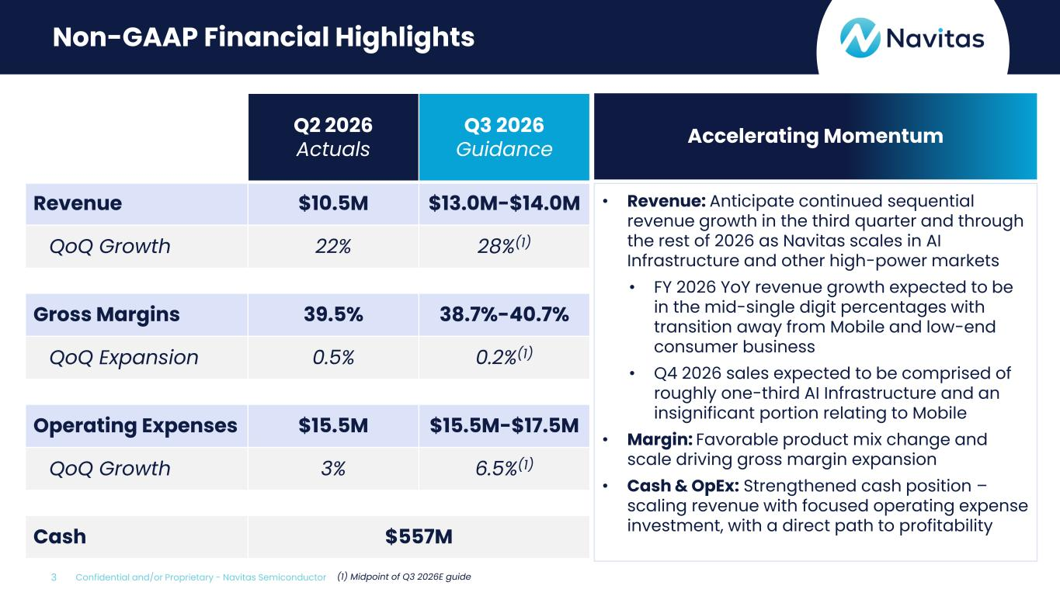
3 Confidential and/or Proprietary - Navitas Semiconductor Non-GAAP Financial Highlights Q2 2026 Actuals Q3 2026 Guidance Revenue $10.5M $13.0M-$14.0M QoQ Growth 22% 28%(1) Gross Margins 39.5% 38.7%-40.7% QoQ Expansion 0.5% 0.2%(1) Operating Expenses $15.5M $15.5M-$17.5M QoQ Growth 3% 6.5%(1) Cash $557M • Revenue: Anticipate continued sequential revenue growth in the third quarter and through the rest of 2026 as Navitas scales in AI Infrastructure and other high-power markets • FY 2026 YoY revenue growth expected to be in the mid-single digit percentages with transition away from Mobile and low-end consumer business • Q4 2026 sales expected to be comprised of roughly one-third AI Infrastructure and an insignificant portion relating to Mobile • Margin: Favorable product mix change and scale driving gross margin expansion • Cash & OpEx: Strengthened cash position – scaling revenue with focused operating expense investment, with a direct path to profitability Accelerating Momentum (1) Midpoint of Q3 2026E guide

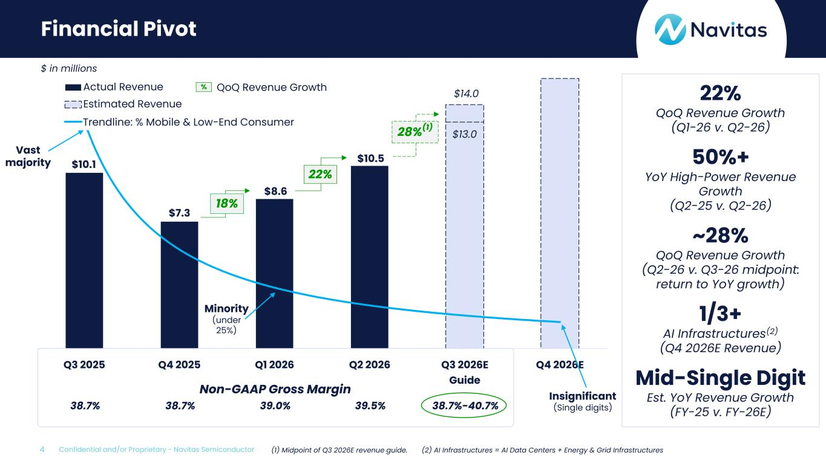
4 Confidential and/or Proprietary - Navitas Semiconductor Financial Pivot $10.1 $7.3 $8.6 $10.5 $13.0 $14.0 0% 10% 20% 30% 40% 50% 60% 70% 80% $- $1.0 $2.0 $3.0 $4.0 $5.0 $6.0 $7.0 $8.0 $9.0 $10.0 $11.0 $12.0 $13.0 $14.0 $15.0 $16.0 Q3 2025 Q4 2025 Q1 2026 Q2 2026 Q3 2026E Guide Q4 2026E Actual Revenue Estimated Revenue Power (% Mobile & Low End Consumer) $ in millions 22% QoQ Revenue Growth (Q1-26 v. Q2-26) 50%+ YoY High-Power Revenue Growth (Q2-25 v. Q2-26) ~28% QoQ Revenue Growth (Q2-26 v. Q3-26 midpoint: return to YoY growth) 1/3+ AI Infrastructures(2) (Q4 2026E Revenue) Mid-Single Digit Est. YoY Revenue Growth (FY-25 v. FY-26E) Non-GAAP Gross Margin 38.7% 38.7% 39.0% 39.5% 38.7%-40.7% Trendline: % Mobile & Low-End Consumer 18% 22% 28%(1) (1) Midpoint of Q3 2026E revenue guide. (2) AI Infrastructures = AI Data Centers + Energy & Grid Infrastructures % QoQ Revenue Growth Vast majority Minority (under 25%) Insignificant (Single digits)

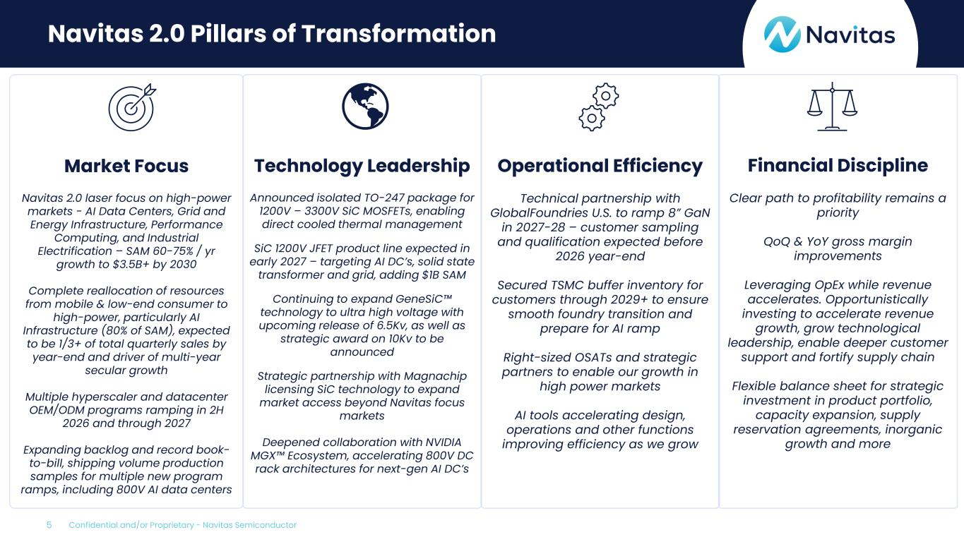
5 Confidential and/or Proprietary - Navitas Semiconductor Navitas 2.0 Pillars of Transformation Market Focus Navitas 2.0 laser focus on high-power markets - AI Data Centers, Grid and Energy Infrastructure, Performance Computing, and Industrial Electrification – SAM 60-75% / yr growth to $3.5B+ by 2030 Complete reallocation of resources from mobile & low-end consumer to high-power, particularly AI Infrastructure (80% of SAM), expected to be 1/3+ of total quarterly sales by year-end and driver of multi-year secular growth Multiple hyperscaler and datacenter OEM/ODM programs ramping in 2H 2026 and through 2027 Expanding backlog and record book- to-bill, shipping volume production samples for multiple new program ramps, including 800V AI data centers Technology Leadership Announced isolated TO-247 package for 1200V – 3300V SiC MOSFETs, enabling direct cooled thermal management SiC 1200V JFET product line expected in early 2027 – targeting AI DC’s, solid state transformer and grid, adding $1B SAM Continuing to expand GeneSiC technology to ultra high voltage with upcoming release of 6.5Kv, as well as strategic award on 10Kv to be announced Strategic partnership with Magnachip licensing SiC technology to expand market access beyond Navitas focus markets Deepened collaboration with NVIDIA MGX Ecosystem, accelerating 800V DC rack architectures for next-gen AI DC’s Operational Efficiency Technical partnership with GlobalFoundries U.S. to ramp 8” GaN in 2027-28 – customer sampling and qualification expected before 2026 year-end Secured TSMC buffer inventory for customers through 2029+ to ensure smooth foundry transition and prepare for AI ramp Right-sized OSATs and strategic partners to enable our growth in high power markets AI tools accelerating design, operations and other functions improving efficiency as we grow Financial Discipline Clear path to profitability remains a priority QoQ & YoY gross margin improvements Leveraging OpEx while revenue accelerates. Opportunistically investing to accelerate revenue growth, grow technological leadership, enable deeper customer support and fortify supply chain Flexible balance sheet for strategic investment in product portfolio, capacity expansion, supply reservation agreements, inorganic growth and more

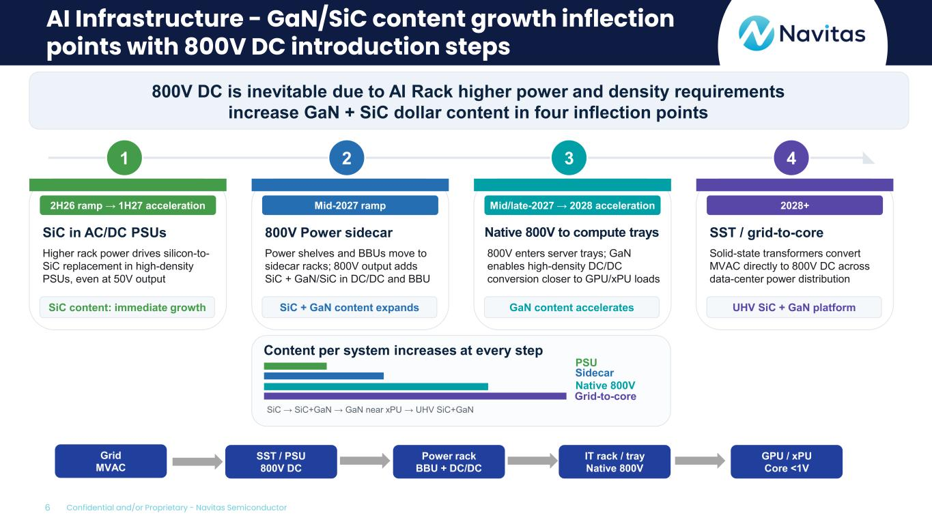
6 Confidential and/or Proprietary - Navitas Semiconductor AI Infrastructure - GaN/SiC content growth inflection points with 800V DC introduction steps 800V DC is inevitable due to AI Rack higher power and density requirements increase GaN + SiC dollar content in four inflection points 1 2H26 ramp → 1H27 acceleration SiC in AC/DC PSUs Higher rack power drives silicon-to- SiC replacement in high-density PSUs, even at 50V output SiC content: immediate growth 2 Mid-2027 ramp 800V Power sidecar Power shelves and BBUs move to sidecar racks; 800V output adds SiC + GaN/SiC in DC/DC and BBU SiC + GaN content expands 3 Mid/late-2027 → 2028 acceleration Native 800V to compute trays 800V enters server trays; GaN enables high-density DC/DC conversion closer to GPU/xPU loads GaN content accelerates 4 2028+ SST / grid-to-core Solid-state transformers convert MVAC directly to 800V DC across data-center power distribution UHV SiC + GaN platform Content per system increases at every step SiC → SiC+GaN → GaN near xPU → UHV SiC+GaN Grid MVAC SST / PSU 800V DC Power rack BBU + DC/DC IT rack / tray Native 800V GPU / xPU Core <1V Sidecar PSU Native 800V Grid-to-core

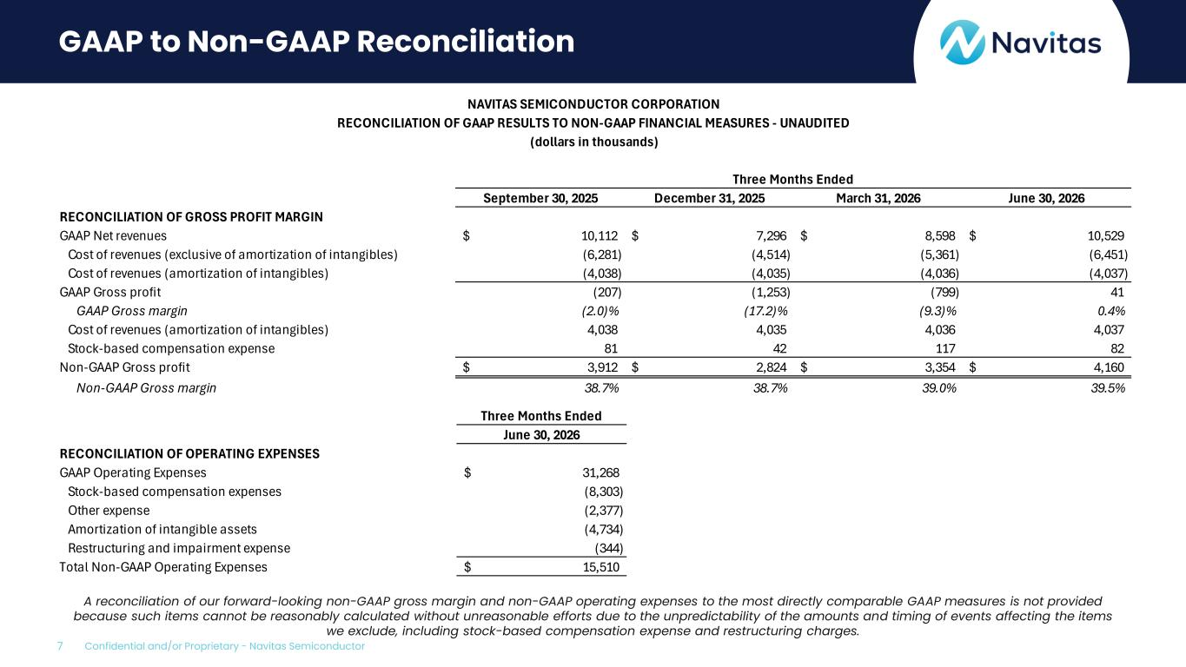
7 Confidential and/or Proprietary - Navitas Semiconductor NAVITAS SEMICONDUCTOR CORPORATION RECONCILIATION OF GAAP RESULTS TO NON-GAAP FINANCIAL MEASURES - UNAUDITED (dollars in thousands) Three Months Ended September 30, 2025 December 31, 2025 March 31, 2026 June 30, 2026 RECONCILIATION OF GROSS PROFIT MARGIN GAAP Net revenues 10,112$ 7,296$ 8,598$ 10,529$ Cost of revenues (exclusive of amortization of intangibles) (6,281) (4,514) (5,361) (6,451) Cost of revenues (amortization of intangibles) (4,038) (4,035) (4,036) (4,037) GAAP Gross profit (207) (1,253) (799) 41 GAAP Gross margin (2.0)% (17.2)% (9.3)% 0.4% Cost of revenues (amortization of intangibles) 4,038 4,035 4,036 4,037 Stock-based compensation expense 81 42 117 82 Non-GAAP Gross profit 3,912$ 2,824$ 3,354$ 4,160$ Non-GAAP Gross margin 38.7% 38.7% 39.0% 39.5% GAAP to Non-GAAP Reconciliation A reconciliation of our forward-looking non-GAAP gross margin and non-GAAP operating expenses to the most directly comparable GAAP measures is not provided because such items cannot be reasonably calculated without unreasonable efforts due to the unpredictability of the amounts and timing of events affecting the items we exclude, including stock-based compensation expense and restructuring charges. Three Months Ended June 30, 2026 RECONCILIATION OF OPERATING EXPENSES GAAP Operating Expenses 31,268$ Stock-based compensation expenses (8,303) Other expense (2,377) Amortization of intangible assets (4,734) Restructuring and impairment expense (344) Total Non-GAAP Operating Expenses 15,510$

