SEC Form 3
FORM 3 | UNITED STATES SECURITIES AND EXCHANGE
 | COMMISSION
 |  |  | OMB APPROVAL
 | Washington, D.C. 20549
 |  |  | OMB Number: | 3235-
 | INITIAL STATEMENT OF BENEFICIAL OWNERSHIP OF |  |  | 0104
 |  |  | Estimated average burden
 | SECURITIES |  |  | 0.5
hours per
response:

Filed pursuant to Section 16(a) of the Securities Exchange Act of 1934
or Section 30(h) of the Investment Company Act of 1940
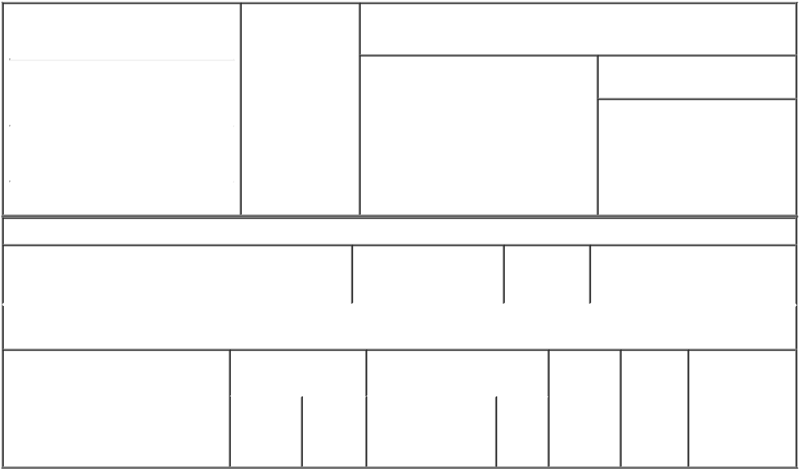

1. Name and Address of Reporting Person |  |  | * | 2. Date of Event
 |  |  |  | Requiring Statement
 | Moxam David
 |  |  |  | (Month/Day/Year)
 |  |  |  | 10/19/2021

3. Issuer Name and Ticker or Trading Symbol

Navitas Semiconductor Corp [ NVTS ]

(Last) | (First) | (Middle)
22 FITZWILLIAM SQUARE
(Street)
DUBLIN | L2 | D02 FH68
(City) | (State) | (Zip)

- Relationship of Reporting Person(s) to Issuer
(Check all applicable)
X Director 10% Owner

Officer (give Other (specify
title below) below)

- If Amendment, Date of Original Filed (Month/Day/Year)

- Individual or Joint/Group Filing (Check Applicable Line)

- Form filed by One Reporting Person

Form filed by More than One Reporting Person

Table I - Non-Derivative Securities Beneficially Owned

 | 1. Title of Security (Instr. 4) | 2. Amount of Securities | 3. Ownership | 4. Nature of Indirect Beneficial
 |  | Beneficially Owned (Instr. | Form: Direct | Ownership (Instr. 5)
 |  | 4) | (D) or Indirect
 |  |  | (I) (Instr. 5)

Table II - Derivative Securities Beneficially Owned

(e.g., puts, calls, warrants, options, convertible securities)

1. Title of Derivative Security (Instr. 4) | 2. Date Exercisable and |  | 3. Title and Amount of Securities |  | 4. | 5. | 6. Nature of
 | Expiration Date |  | Underlying Derivative Security |  | Conversion | Ownership | Indirect Beneficial
 | (Month/Day/Year) |  | (Instr. 4) |  | or Exercise | Form: | Ownership (Instr.
 |  |  |  |  | Price of | Direct (D) | 5)
 |  |  |  | Amount
 |  |  |  |  | Derivative | or Indirect
 |  |  |  | or | Security | (I) (Instr. 5)
 |  |  |  | Number
 | Date | Expiration |  | of
 | Exercisable | Date | Title | Shares

Explanation of Responses:

No securities are beneficially owned.

 | /s/ Paul Delva, Attorney- |  |  | 10/20/2021
 | in-Fact
 | ** Signature of Reporting |  |  | Date
 | Person
Reminder: Report on a separate line for each class of securities beneficially owned directly or indirectly.
* If the form is filed by more than one reporting person, see Instruction 5 (b)(v).

- Intentional misstatements or omissions of facts constitute Federal Criminal Violations See 18 U.S.C. 1001 and 15 U.S.C. 78ff(a). Note: File three copies of this Form, one of which must be manually signed. If space is insufficient, see Instruction 6 for procedure.
Persons who respond to the collection of information contained in this form are not required to respond unless the form displays a currently valid OMB Number.

